# Lesson 66 单词讲解

1. bomber n. 轰炸机

bomb n. 炸弹 v. 轰炸

1. remote adj. 偏僻的，遥远的 a remote place

n. 遥控器

1. rediscover v. 重新发现repeat v. 重复 L2 retell v. 复 述rebuild v. 重建

restore v. 修复，恢复，把……放回

1. rescue v. 营救／n. 营救，救援

rescue operations 营救行动

1. package v. 把……打包

n. 包裹 a small package of cigars

pack v. 包裹，打包

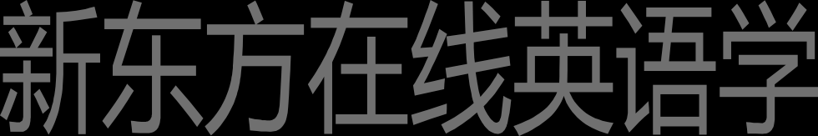a packing case

1. preserve v. 保护

pre-

prepare v. 做准备

preview v. 预演，预告

precaution n. 预防措施 L74

Lancaster ['læŋkəstə] n.兰开斯特

2 bomber ['bɔmə] n.轰炸机

3 remote [ri'məut] a.偏僻的

4 Pacific [pə'sifik] n.太平洋

5 damage ['dæmidʒ] v.毁坏

6 wreck [rek] n.残骸

7 rediscover [ri:di'skʌvə] v.重新发现

8 aerial ['eəriəl] a.航空的

9 survey ['sə:vei] n.调查

10 rescue ['reskju:] v.营救

11package ['pækidʒ] v.把…打包

12 enthusiast[in'θju:ziæst] n.热心人

13 restore[ri'stɔ:] v.修复

14 imagine[i'mædʒin] v.想像

15 packing ['pækiŋ] 包装箱

16 colony ['kɔləni] n.群

17 bee [bi:] n.蜂

18 hive [haiv] n.蜂房

19 preserve [pri'zə:v] v.保护

20 beeswax ['bi:zwæks] n.蜂蜡

# Lesson 66 课文&语法讲解

本课重点:

复习 have 的用法实义动词

助动词

have 的用法实义动词1.“有”

1. “吃喝玩乐做”
2. 使役动词 “使……”

助动词（无实义，用于完成时态中）

1. sweet as honey 省略了一个as

as sweet as honey as… as… L32

原级比较 甜的像蜂蜜一样

as busy as bees

as sticky as glue

1. … a Lancaster bomber crashed on Wallis Island, a remote place in the South Pacific, a long way west of Samoa.

crash v.

同位语

1. The plane wasn’t too badly damaged, but … the crash was forgotten and the wreck remained undisturbed.

crash n.

undisturbed adj. 不受打扰的

disturb v. 打扰

Do not disturb. 请勿打扰

1. By this time, a Lancaster bomber in reasonable condition was rare and worth rescuing.

in … condition 处于，，状态

in + good / bad / perfect + condition

1. By this time, a Lancaster bomber in reasonable condition was rare and worth rescuing.

be worth doing

These books are worth reading. The idea is worth considering.

Whatever is worth doing is worth doing well.

1. The French authorities had the plane packaged and moved in parts back to France.

L58:The vicar has been asked to have the tree cut down… have sth. done

使某事被做（不是本人亲自做，而是让其他人去做）

have sth. done

使某事被做 （不是本人亲自做，而是让其他人去做）

I washed my car.

I had my car washed.

I will cut my hair tomorrow.

I will have my hair cut tomorrow.

5. The French authorities had the plane packaged and moved in parts back to France.

The French authorities had the plane packaged

and (the French authorities had the plane) moved in parts back to France.

并列句的省略

Now a group of enthusiasts are going to have the plane restored.

…but the group will need to have only three of them rebuilt.

A colony of bees had turned the engine into a hive and it was totally preserved in beeswax!

# Lesson 66 知识拓展

本课重点:

复习 have 的用法

使役动词 “使……”

have sth. done “使某事被做”

I washed my car.

I had my car washed.

have 使役动词 “使……”

1. have sth. done “使某事被做”
2. have sb. do sth. “使某人做某事”

I will have my lawyer talk with you about the details.

have 使役动词 “使……”

1. have sth. done “使某事被做”
2. have sb. do sth. “使某人做某事”
3. have ab. doing sth. “使某人持续做某事”

The bad news had everybody fearing that disasters would happen soon.

have 使役动词 “使……”

1. have sth. done “使某事被做”
2. have sb. do sth. “使某人做某事”
3. have ab. doing sth. “使某人持续做某事”

